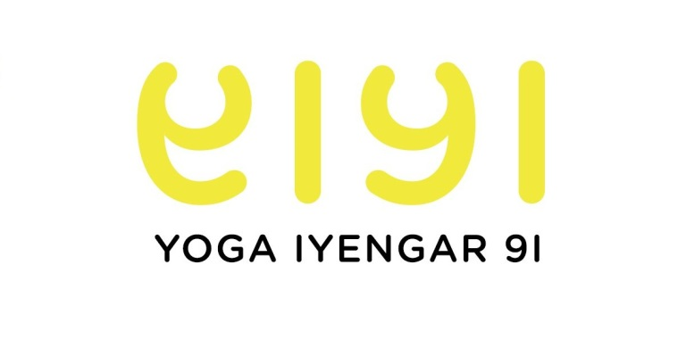
3-DAY MINI-WORKSHOP
11-13 April 2016

Rain Aronson www.yoga109.com
At the end of his life BKS Iyengar expressed a wish for the community of Iyengar teachers: “May my end be your beginning”. ﻿﻿
Rain Aronson is following along the lines of this wish. Rather than fixing the practice in the technical advances and teaching points discovered at a period of Iyengar’s life, she focuses on keeping the activity of searching alive, so that the practice continues to move forward.

The Workshop

Developing a yoga practice requires curiosity and will power. This short but intense three-day program comprises three three-hour sessions, each one systematically exploring a different aspect of the practice.﻿﻿﻿

The level is suitable for all students, regardless of previous experience. You develop from the level you are.

The program will be conducted in English.

Days and Times: Monday, Tuesday, Wednesday 9:30am-12:30am

Attendance Options and Corresponding Fees:
Monday only = 60€
Monday and Tuesday = 120€
Monday, Tuesday, Wednesday = 150€
Please note:
Attendance of the Monday session is prerequisite for Tuesday; attendance of the Tuesday session is prerequisite for Wednesday.
Should a session be fully booked, priority will be given to those attending three days.

Registration: Contact Marie Fortunato, at fortunato.shanghai@gmail.com

Venue: YOGA IYENGAR 91, 91 FG Saint-Martin 75010 PARIS, FRANCE

